Kodak photographs from the visit of J. T. Arundel to Jarvis Island in 1909.
These photographs were likely taken by Arundel’s daughter Sydney.

John T Arundel, son of a LMS official, was born in England in 1841. His early work for a London firm with interests in guano, or phosphate, took him into the Pacific. By 1892 Arundel had formed his own company, J.T. Arundel & Co, which had acquired concessions over a number of islands in what is now Kiribati – Kanton, Enderbury, Gardner, Hull, Flint and Manra (Sydney) – to plant coconuts, make copra and mine phosphate. The Pacific Islands Company Limited (PIC) was formed in May 1897 and, in 1898, took over plantations and trade stores of Henderson & McFarlane Ltd in the mid-Pacific. Lord Stanmore, formerly Sir Arthur Gordon, the first Governor of Fiji and High Commissioner for the Western Pacific, was Chairman of the PIC. Arundel became its vice-chairman. PIC business interests stretched from Mexico to Fiji, with ready markets for copra and phosphate in New Zealand, Australia, the USA, Japan and the UK.

These pictures come from the National Archives of Australia: List of Kodaks - by Mr J T Arundel and Miss Arundel, Series R32: Collection of black and white and colour photograph albums, prints, negatives and slides of islands phosphate mining operations

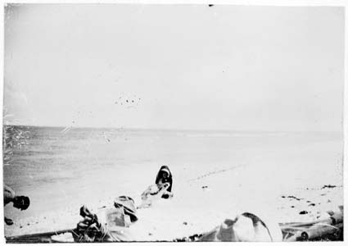
Beach opposite the Beacon

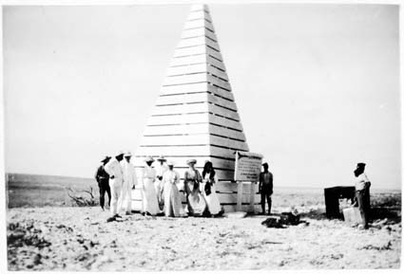
Beacon completed - Notice Board on the right hand or lee side facing the landing

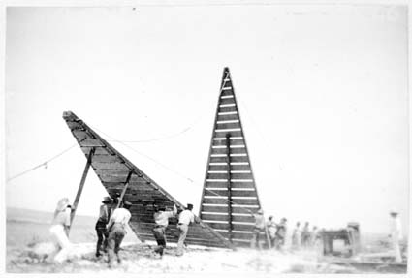
Beacon in course of erection

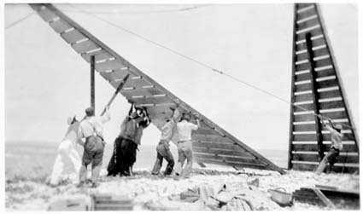
Lifting one section of the Beacon

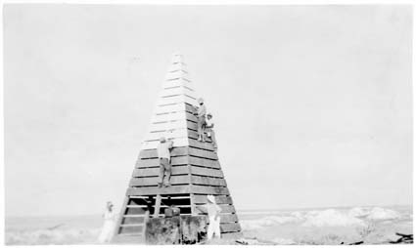
Painting the Beacon

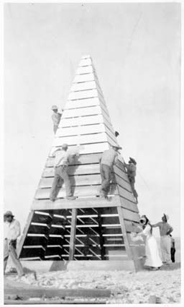
Painting the Beacon

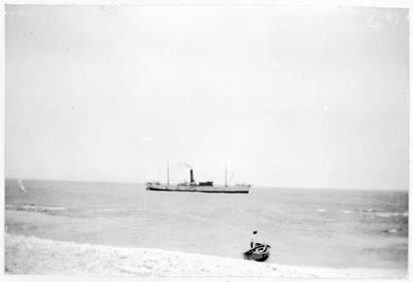
Steam launch going out through passage - SS OCEAN QUEEN waiting

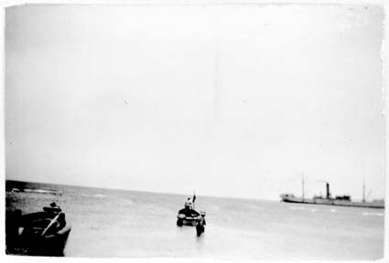
Similar view of - Steam launch going out through passage - SS OCEAN QUEEN waiting - but shewing breakers at each side of passage

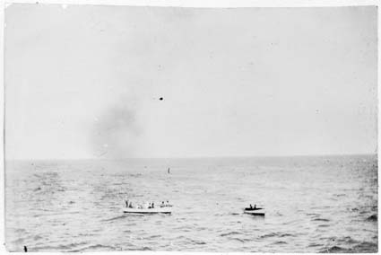
Steam launch towing boat to OCEAN QUEEN

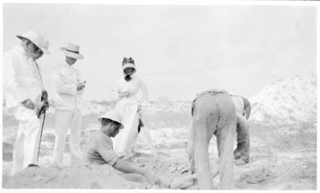
Taking samples from hole dug for that purpose Old Guano heaps all around - From left to right Messrs Arundel, Jay and Bunclark, and Miss Bright - Natives digging

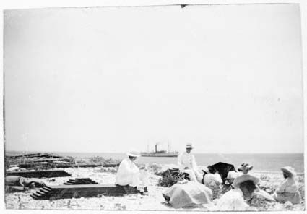
Waiting for lunch

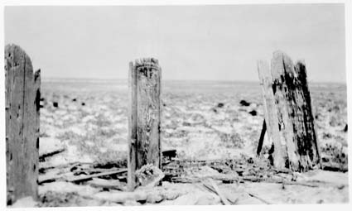
Old graveyard - The centre head piece marked S F no doubt marks the resting place of Squire Flockton who is referred to in Report Number 172, Paragraph 2

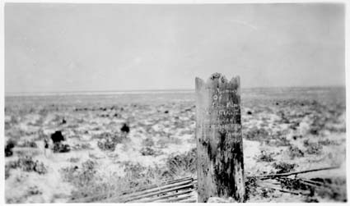
The fourth grave in the old Cemetery

